**Chapter 1. A Review of Machine Learning**

To condense fact from the vapor of nuance

--- Neal Stephenson, Snow Crash

**The Learning Machines**

Interest in machine learning has exploded over the past decade. You see machine learning in computer science programs, industry conferences, and the *Wall Street Journal* almost daily. For all the talk about machine learning, many conflate what it can do with what they wish it could do. Fundamentally, *machine learning* is using algorithms to extract information from raw data and represent it in some type of *model*. We use this model to infer things about other data we have not yet modeled.

Neural networks are one type of model for machine learning; they have been around for at least 50 years. The fundamental unit of a neural network is a “node,"  loosely based on the biological neuron in the mammalian brain. The connections between neurons, too, are modeled on biological brains, as is the way these connections develop over time (with “training”). We’ll dig deeper into how these models work over the next two chapters.

In the mid-1980’s and early 1990’s many important architectural advancements were made in neural networks. However, the amount of time and data needed to get good results slowed adoption and interest cooled. In the early 2000’s computational power exploded and the industry saw a “Cambrian explosion” of computational techniques that were not possible before. Deep learning emerged from that decade’s explosive computational growth as a serious contender in the field, winning many important machine learning competitions. The interest has not cooled leading into 2017 where we see deep learning mentioned in every corner of machine learning today.

We’ll discuss our definition of deep learning more in-depth in section that follows. This book is structured such that the practitioner can pick it up off the shelf and:

* review the relevant basic parts of linear algebra and machine learning
* review the basics of neural networks
* study the four major architectures of deep networks
* use the examples in the book to try out variations of practical deep networks

We hope that the reader will find the material practical and approachable. Let’s kick off the book with a quick primer on what machine learning is about and some of the core concepts the reader will need to better understand the rest of the book.

**How Can Machines Learn?**

To define how machines can learn we need to define what we mean by “learning”. In everyday parlance, when we say learning we mean something like “getting knowledge of by studying, experience, or being taught.” Sharpening our focus a bit, we can think of *machine learning* as using algorithms for acquiring structural descriptions from data examples. A computer learns something about the structures that represent the information in the raw data. Structural descriptions are another term for the models we build to contain the information extracted from the raw data, and we can use those structures or models to predict unknown data. Structural descriptions (or models) can be can take many forms including:

* decision trees
* linear regression models
* neural network weights

Each model type has a different way of applying rules to known data to predict unknown data. Decision trees create a set of rules in the form of a tree structure and linear models create a set of parameters to represent the input data.

Neural networks have what is called a parameter vector representing the weights on the connections between the nodes in the network. We’ll describe the details of this type of model later on in this chapter.

**Machine Learning vs Data Mining**

Data Mining has been around for many decades and like many terms in machine learning gets misunderstood or used poorly. For the context of this book we consider the practice of “data mining” to be “extracting information from data”. Machine learning differs in that it refers to the algorithms used during data mining for acquiring the structural descriptions from the raw data. A simple way to think of data mining is:

* To learn concepts
  + we need examples of raw data
* Examples are made of rows or instances of the data
  + Which show specific patterns in the data
* The machine learns concepts from these patterns in the data
  + Through algorithms in machine learning
* Overall this process can be considered “data mining”

Arthur Samuel, a pioneer in artificial intelligence at IBM and Stanford[1](https://www.safaribooksonline.com/library/view/Deep+Learning/9781491924570/ch01.html#idm139836507711616), defined machine learning as a

field of study that gives computers the ability to learn without being explicitly programmed.

Samuel created software that could play checkers and adapt its strategy as it learned to associate the probability of winning and losing with certain dispositions of the board. That fundamental schema of searching for patterns that lead to victory or defeat, then recognizing and reinforcing successful patterns, underpins machine learning and artificial intelligence to this day.

The concept of machines that could learn to achieve goals on their own has captivated us for decades. This was perhaps best expressed by the modern grandfathers of Artificial Intelligence, Stuart Russell[2](https://www.safaribooksonline.com/library/view/Deep+Learning/9781491924570/ch01.html#idm139836519111952) and Peter Norvig[3](https://www.safaribooksonline.com/library/view/Deep+Learning/9781491924570/ch01.html#idm139836519110992), when they wrote in the book “Artificial Intelligence: A Modern Approach”[4](https://www.safaribooksonline.com/library/view/Deep+Learning/9781491924570/ch01.html#idm139836519109952):

How is it possible for a slow, tiny brain, whether biological or electronic, to perceive, understand, predict, and manipulate a world far larger and more complicated than itself?

This quote alludes to ideas around how the concepts of learning were inspired from processes and algorithms discovered in nature. To set Deep Learning in context visually, we illustrate our conception of the relationship between Artificial Intelligence, Machine Learning, and Deep Learning in the diagram below.

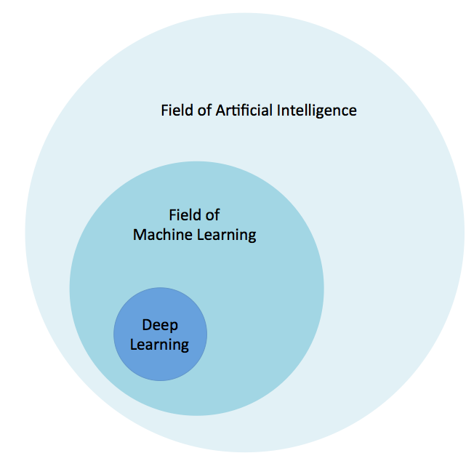

**Figure 1-1. The Relationship Between Artificial Intelligence and Deep Learning**

The field of Artificial Intelligence is broad and has been around for a long time. Deep Learning is a subset of the field of machine learning which is a sub-field of Artificial Intelligence. Let’s now take a quick look at another of the roots of deep learning: how neural networks are inspired by biology.

**Biological Inspiration**

Biological neural networks (brains) are composed of roughly 86 billion neurons connected to many other neurons.

**Total Connections in the Human Brain**

Researchers conservatively estimate there are over 500 trillion connections between neurons in the human brain. Even the largest artificial neural networks today come no where close to this number.

From an information processing point of view a biological neuron is an excitable unit that can process and transmit information via electrical and chemical signals. A neuron in the biological brain is considered a main component of the brain, spinal cord of the central nervous system, and the ganglia of the peripheral nervous system. As we’ll see later in this chapter, artificial neural networks are far simpler in their comparative structure.

**Comparing Biological with Artificial**

Biological neural networks are considerably (several orders of magnitude) more complex than the artificial neural network versions!

There are two main properties of artificial neural networks that follow the general idea of how the brain works. First is that the most basic unit of the neural network is the artificial neuron (or *node* in shorthand). Artificial neurons are modeled on the biological neurons of the brain and like biological neurons they are stimulated by inputs. These artificial neurons pass on some—but not all—information they receive to other artificial neurons, often with transformations. As we progress through this chapter we’ll go into detail about what these transformations are in the context of neural networks.

Second, much as the neurons in the brain can be trained to pass forward only signals that are useful in achieving the larger goals of the brain, the neurons of a neural network can be trained to pass along only useful signals. As we move through this chapter we’ll build on these ideas and see how artificial neural networks are able to model their biological counterparts through bits and functions.

**Biological Inspiration Across Computer Science**

Biological inspiration is not limited to artificial neural networks in computer science. Over the past 50 years academic research has explored other topics in nature for computational inspiration such as:

* ants
* termites[5](https://www.safaribooksonline.com/library/view/Deep+Learning/9781491924570/ch01.html#idm139836507705024)
* bees
* genetic algorithms

Ant colonies[6](https://www.safaribooksonline.com/library/view/Deep+Learning/9781491924570/ch01.html#idm139836507702624), for instance, were shown by researchers to be a powerful decentralized computer where no single ant is a central point of failure. Ants constantly switch tasks to find near optimal solutions for load balancing through meta-heuristics such as quantitative stigmergy. Ant colonies are able to perform midden tasks, defense, nest construction, and forage for food while maintaining near optimal number of workers on each task based on the relative need with no one directly coordinating the work.

**What is Deep Learning?**

Deep learning has been a challenge to define for many as it has changed forms slowly over the past decade. One useful definition specifies that deep learning deals with a “neural network with more than two layers”. The problematic aspect to this definition is that it makes deep learning sound as if has been around since the 1980’s. We feel that neural networks had to transcend architecturally from the earlier network styles (in conjunction with a lot more processing power) before showing the spectacular results seen in more recent years. Some of the facets in this evolution of neural networks include:

* more neurons than previous networks
* more complex ways of connecting layers / neurons in NNs
* explosion in the amount of computing power available to train
* automatic feature extraction

For the purposes of this book we’ll define deep learning as neural networks with large number of parameters and layers in one of four fundamental network architectures:

* Unsupervised Pre-Trained Networks
* Convolutional Neural Networks
* Recurrent Neural Networks
* Recursive Neural Networks

There are some variations of the above architectures—a hybrid convolutional and recurrent neural network, for example, as well. For the purpose of this book we’ll consider the above four architectures as our focus.

Automatic feature extraction is another one of the great advantages that deep learning has over traditional machine learning algorithms. By feature extraction, we mean the network’s process of deciding which characteristics of a dataset can be used as indicators to label that data reliably. Historically, machine learning practitioners have spent months, years, and sometimes decades of their lives manually creating exhaustive feature sets for the classification of data. At the time of deep learning’s big bang starting in 2006, state-of-the-art machine learning algorithms had absorbed decades of human effort, as they accumulated relevant features by which to classify input. Deep learning has surpassed those conventional algorithms in accuracy for almost every data type with minimal tuning and human effort. These deep networks can help data science teams save their blood, sweat, and tears for more meaningful tasks.

**Going Down the Rabbit Hole**

Deep learning has penetrated the computer science consciousness beyond most techniques in recent history. This is in part due to how it has shown not only top flight accuracy in machine learning modeling but also demonstrated generative mechanics that fascinate even the non-computer scientist. One example of this would be the art generation demos where a deep network was trained on a particular famous painter’s works and the network was able to render other photographs in the painter’s own style.



**Figure 1-2. Stylized Images by Gatys et. al., 2015**[**7**](https://www.safaribooksonline.com/library/view/Deep+Learning/9781491924570/ch01.html#idm139836516025792)

This begins to enter into many philosophical discussions such as “can machines be creative?” and then “what is creativity?”. We’ll leave that discussion for the reader to ponder at a later time. Machine learning has evolved over the years like the seasons change, subtle but steady until you wake up one day and a machine has won “Jeopardy” or beat a Go Grand Master.

Can machines be intelligent and take on human level intelligence? What is artificial intelligence and how powerful could it become? These questions have yet to be answered and will not be completely answered in this book. We simply seek to illustrate to the reader some of the shards of machine intelligence we can imbue our environment with today through the practice of Deep Learning.

**For Extended Discussion on Artificial Intelligence**

The reader should take a look at the Appendix at the back of the book on “What is Artificial Intelligence?”

**Framing the Questions**

Understanding the basics in applying machine learning is best framed by asking the correct questions to start with. We need to define:

* What is the input data we want to extract information (model) from?
* What kind of model is most appropriate for this data?
* What kind of answer would we like to elicit from new data based on this model?

If we can answer these 3 questions we can setup a machine learning workflow that will build our model and produce our desired answers. To better support this workflow let’s review some of the core concepts we need to be aware of to practice machine learning. We’ll then come back to how these come together in machine learning and then use that information to better inform our understanding of both neural networks and deep learning.

**The Math behind Machine Learning: Linear Algebra**

Linear algebra is the bedrock of machine learning and deep learning. Linear algebra provides us with the mathematical underpinnings to solve the equations we use to build models.

**For More on Linear Algebra**

A great primer on linear algebra is James E. Gentle’s “Matrix Algebra: Theory, Computations, and Applications in Statistics”[8](https://www.safaribooksonline.com/library/view/Deep+Learning/9781491924570/ch01.html#idm139836507342704)

Let’s take a look at some core concepts from this field before we move on starting with the basic concept called a “scalar”.

**Scalars**

In mathematics when the term scalar is mentioned we are concerned with elements in a vector. A scalar is a real number and an element of a field used to define a vector space.

In computing the term scalar is synonymous with the term variable and is a storage location paired with a symbolic name. This storage location holds an unknown quantity of information called a “value”.

**Vectors**

For our use we define a vector as:

*For a positive integer n, a vector is an n-tuple, ordered (multi)set, or array of n numbers, called elements or scalars.*

What we’re saying is that we want to create a data structure called a vector via a process called vectorization. The number of elements in the vector is called the “order” (or “length”) of the vector. Vectors can also represent points in n-dimensional space. In the spatial sense, the Euclidean distance from the origin to the point represented by the vector gives us the “length” of the vector.

In mathematical texts we often see vectors written as:

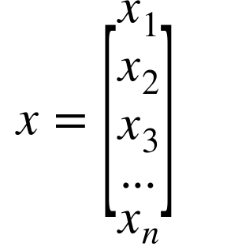

Or

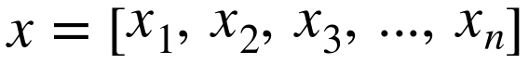

There are many different ways to handle the vectorization and many pre-processing steps can be applied giving us different grades of effectiveness on the output models. We’ll cover more on the topic of converting raw data into vectors later on in this chapter and then more fully in [Chapter 5](https://www.safaribooksonline.com/library/view/Deep+Learning/9781491924570/ch05.html#building_deep_networks).

**Matrices**

Consider a matrix to be a group of vectors that all have the same dimension (number of columns). In this way a matrix is a two-dimensional array where we have rows and columns.

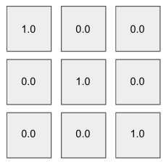

**Figure 1-3. A 3x3 Matrix**

If our matrix is said to be a n x m matrix then it has n rows and m columns. In [Figure 1-3](https://www.safaribooksonline.com/library/view/Deep+Learning/9781491924570/ch01.html#a-3x3-matrix) above we see a 3 x 3 matrix illustrating the dimensions of a matrix. Matrices are a core structure in linear algebra and machine learning as we’ll show as we progress through this chapter.

**Tensors**

A tensor is a multidimensional array at the most fundamental level. It is a more general mathematical structure than a vector. We can look at a vector as simply a subclass of tensors.

With tensors the rows extend along the y-axis and the columns along the x-axis. Each axis is a dimension and tensors have additional dimensions. Tensors also have a rank. Comparatively, a scalar is of rank 0 and a vector is rank 1. We also see that a matrix is rank 2. Any entity of rank 3 and above are considered tensors.

**Hyperplanes**

Another linear algebra object the reader should be aware of is the hyperplane. The hyperplane is a subspace of one dimension less than its ambient space in the field of geometry. In a 3-dimensional space the hyperplanes would be of 2-dimensions. In a single dimension (a number line) hyperplanes end up as 1-dimensional dots.

A hyperplane is a mathematical construct that divides an n-dimensional space into separate “parts” and therefore is useful in applications like classification.​Optimizing the parameters of the hyperplane is a core concept in linear modeling as we’ll see further on in this chapter.

**Relevant Mathematical Operations**

In this section we briefly review common linear algebra operations the practitioner should note.

**Dot Product**

A core linear algebra operation we see often in machine learning is the dot product. The dot product is sometimes called the “scalar product” or “inner product”. The dot product takes two vectors of the same length and returns a single number. This is done by matching up the entries in the two vectors, multiplying them and then summing up the products thus obtained. Without getting too mathematical (immediately), it is important to mention that this single number encodes a lot of information.

To begin with, the dot product is a measure how big the individual elements are in each vector. Two vectors with rather large values can give rather large results and two vectors with rather small values can give rather small values. When the relative values of these vectors are accounted for mathematically with something called normalization the dot product is a measure of how similar these vectors are. This mathematical notion of a dot product of two normalized vectors is called the cosine similarity.

**Element-Wise Product**

Another common linear algebra operation we see in practice is the element-wise product (or the “Hadamard product”). This operation takes two vectors of the same length and produces a vector of the same length with each corresponding element multiplied together from the 2 source vectors.

**Outter Product**

This is known as the “tensor product” of two input vectors. We take each element of a column vector and multiply it by all of the elements in a row vector creating a new row in the resultant matrix.

**Converting Data Into Vectors**

In the course of working in machine learning and data science we need to analyze all types of data. A key requirement is being able to take each data type and represent it as a vector. In machine learning we touch many types of data (text, timeseries, audio, image, video)

So why can’t we just feed raw data to our learning algorithm and just let it handle everything? The issue is that machine learning is based on linear algebra and solving sets of equations. These equations expect floating point numbers as input so we need to have a way to translate the raw data into sets of floating point numbers. We’ll connect these concepts together in the next section on solving these sets of equations. An example of raw data would be the canonical iris dataset[9](https://www.safaribooksonline.com/library/view/Deep+Learning/9781491924570/ch01.html#idm139836508144448):

5.1,3.5,1.4,0.2,Iris-setosa

4.9,3.0,1.4,0.2,Iris-setosa

4.7,3.2,1.3,0.2,Iris-setosa

7.0,3.2,4.7,1.4,Iris-versicolor

6.4,3.2,4.5,1.5,Iris-versicolor

6.9,3.1,4.9,1.5,Iris-versicolor

5.5,2.3,4.0,1.3,Iris-versicolor

6.5,2.8,4.6,1.5,Iris-versicolor

6.3,3.3,6.0,2.5,Iris-virginica

5.8,2.7,5.1,1.9,Iris-virginica

7.1,3.0,5.9,2.1,Iris-virginica

Another example might be a raw text document:

Go, Dogs. Go!

Go on skates

or go by bike.

Both cases involve raw data of different types yet both need some level of vectorization to be of the form we need to do machine learning. At some point we want our input data to be of the form of a matrix but we can convert the data into intermediate representations (e.g. “svmlight” file format, as seen below).  We want our machine learning algorithm’s input data to look more like the serialized sparse vector format svmlight below:

1.0 1:0.7500000000000001 2:0.41666666666666663 3:0.702127659574468 4:0.5652173913043479

2.0 1:0.6666666666666666 2:0.5 3:0.9148936170212765 4:0.6956521739130436

2.0 1:0.45833333333333326 2:0.3333333333333336 3:0.8085106382978723 4:0.7391304347826088

0.0 1:0.1666666666666665 2:1.0 3:0.021276595744680823

2.0 1:1.0 2:0.5833333333333334 3:0.9787234042553192 4:0.8260869565217392

1.0 1:0.3333333333333333 3:0.574468085106383 4:0.47826086956521746

1.0 1:0.7083333333333336 2:0.7500000000000002 3:0.6808510638297872 4:0.5652173913043479

1.0 1:0.916666666666667 2:0.6666666666666667 3:0.7659574468085107 4:0.5652173913043479

0.0 1:0.08333333333333343 2:0.5833333333333334 3:0.021276595744680823

2.0 1:0.6666666666666666 2:0.8333333333333333 3:1.0 4:1.0

1.0 1:0.9583333333333335 2:0.7500000000000002 3:0.723404255319149 4:0.5217391304347826

0.0 2:0.7500000000000002

This format can quickly be read into a matrix and a column vector for the labels (the first number in each row above). The rest of the indexed numbers in the row are inserted into the proper slot in the matrix as “features” at runtime to get ready for various linear algebra operations during the machine learning process. We’ll discuss the various formats for vectors and the process of vectorization in more detail in [Chapter 8](https://www.safaribooksonline.com/library/view/Deep+Learning/9781491924570/ch08.html#vectorization).

A very common question is “why do machine learning algorithms want the data represented (typically) as a (sparse) matrix?” To understand that let’s make a quick detour into the basics of solving systems of equations.

**Solving Systems of Equations**

In the world of linear algebra we are interested in solving systems of linear equations of the form:

Ax = b

Where A is a matrix our set of input row vectors and b is the column vector of labels for each vector in the A matrix. If we take the first 3 rows of serialized sparse output from the above diagram and place the values in its linear algebra form it looks like:

|  |  |  |  |
| --- | --- | --- | --- |
| Column 1 | Column 2 | Column 3 | Column 4 |
| 0.7500000000000001 | 0.41666666666666663 | 0.702127659574468 | 0.5652173913043479 |
| 0.6666666666666666 | 0.5 | 0.9148936170212765 | 0.6956521739130436 |
| 0.45833333333333326 | 0.3333333333333336 | 0.8085106382978723 | 0.7391304347826088 |

This matrix of numbers is our A variable in our equation and each independent value or value in each row is considered a feature of our input data.

**What is a Feature?**

A feature in machine learning is any column value in the input matrix A that we’re using as in independent variable. Features can be taken straight from the source data but most of the time we’re going to use some sort of transformation to get the raw input data into a form that is more appropriate for modeling.

An example would be a column of input that had 4 different text labels in the source data. We’d need to scan all of the input data and index the labels being used. We’d then need to normalize these values (0, 1, 2, 3) between 0.0 and 1.0 based on each label’s index for every row’s column value. These types of transforms greatly help machine learning to find better solutions to modeling problems. We’ll see more techniques for vectorization transforms in [Chapter 5](https://www.safaribooksonline.com/library/view/Deep+Learning/9781491924570/ch05.html#building_deep_networks).

We want to find coefficients for each column in a given row for a predictor function that give us the output b, or the label for each row. The labels from the above serialized sparse vectors would be:

|  |
| --- |
| Labels |
| 1.0 |
| 2.0 |
| 2.0 |

The coefficients mentioned above become the x column vector (also called “parameter vector”) shown in the diagram below:

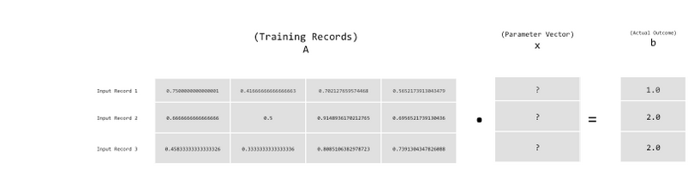

**Figure 1-4. Visualizing the Equation Ax=b**

This system is said to be “consistent” if there exists a parameter vector x such that the solution to this equation can be directly written as

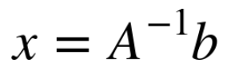

Its important to delineate the expression  from the method of actually computing the solution. This expression only represents the solution itself. The variable  is the matrix A inverted and is computed through a process called “matrix inversion”. Given that not all matrices can be inverted, we’d like a method to solve this equation that does not involve matrix inversion. One method is called matrix decomposition. An example of matrix decomposition in solving systems of linear equations is using lower upper (LU) decomposition to solve for the matrix A. Beyond matrix decomposition let’s take a look at the general methods for solving sets of linear equations.

**Methods for Solving Systems of Linear Equations**

There are two general methods for solving a system of linear equations. The first is called the “direct method” where we know algorithmically there are a fixed number of computations. The other approach is a class of methods known as “iterative methods” where through a series of approximations and a set of termination conditions we can derive the parameter vector x. The direct class of methods is particular effective when we can fit all of the training data (A and b) in memory on a single computer. Well-known examples of the direct method of solving sets of linear equations are “Gaussian Elimination” and the “Normal Equations”.

**Iterative Methods**

The iterative class of methods is particular effective when our data doesn’t fit into main memory on single computer and looping through individual records from disk allows us to model a much larger amount of data. The canonical example of iterative methods most commonly seen in machine learning today is “Stochastic Gradient Descent” as we’ll discuss later in this chapter. Other techniques in this space are “Conjugate Gradient Methods” and “Alternating Least Squares” (discussed further on in [Chapter 3](https://www.safaribooksonline.com/library/view/Deep+Learning/9781491924570/ch03.html#fundamentalls_of_deep_networks) of this book). Iterative methods have also been shown to be effective in scale-out methods where we not only loop through local records, but the entire dataset is sharded across a cluster of machines and periodically the parameter vector is averaged across all agents and then updated at each local modeling agent (described in more detailed in [Chapter 9](https://www.safaribooksonline.com/library/view/Deep+Learning/9781491924570/ch09.html#dl_and_dl4j_on_spark)).

**Iterative Methods and Linear Algebra**

At the mathematical level we want to be able to operate on our input dataset with these algorithms. This constraint requires us to convert our raw input data into the input matrix A. This quick overview of linear algebra gives us the “why” for going through the trouble to vectorize data. Throughout the book we show code examples of converting the raw input data into the input matrix A, giving the reader the “how”. The mechanics of how we vectorize our data also impacts the results of the learning process. As we’ll see later in the book, how we handle data in the pre-process stage before vectorization can create more accurate models.

**The Math Behind Machine Learning: Statistics**

Let’s review just enough statistics to let this chapter move forward. We need to highlight some basic concepts in statistics such as

* probabilities
* distributions
* likelihood

There are also some other basic relationships we’d like to highlight in descriptive statistics and inferential statistics. Descriptive statistics includes:

* histograms
* boxplots
* scatter plots
* mean
* standard deviation
* correlation coefficient

This contrasts with how inferential statistics are concerned with techniques for generalizing from a sample to a population. Examples of inferential include:

* p-values
* credibility intervals

The relationship between probability and inferential statistics is that:

* probability reasons from the population to the sample (“deductive reasoning”)
* inferential statistics reasons from the sample to the population

Before we can understand what a specific sample tells us about the source population we need to understand the uncertaintity associated with taking a sample from a given population.

With regards to general statistics we won’t linger on what is an inherently broad topic already covered in depth by other books. This section is in no way meant to serve as a true statistics review, rather to direct the reader towards relevant topics that can be investigated in further depth from other resources. With that disclaimer out of the way, let’s start off by defining probability in statistics.

**Probability**

We define probability of an event E as a number always between 0 and 1. In this context the value 0 infers that the event E has no chance of occurring and the value 1 means that the event E is certain to occur. Many times we’ll see this probability expressed as a floating point number yet we can also express it as a percentage between 0% and 100%. We will not see valid probabilities lower than 0% and greater than 100%. An example would be a probability of 0.35 expressed as 35% (e.g. 0.35 x 100 == 35%).

The canonical example of measuring probability is observing how many times a fair coin flipped comes up heads or tails (e.g. 0.5 for each side). The probability of the sample space is always 1 as the sample space represents all possible outcomes for a given trial. As we can see with the two outcomes (“heads” and its complement, “tails”) for the flipped coin, 0.5 + 0.5 == 1.0 as the total probability of the sample space must always add up to 1. We express the probability of an event as:

P( E ) = 0.5

And we read this as:

the probability of an event E is 0.5

**Probability vs Odds, Explained**

Many times practitioners new to statistics or machine learning will conflate the meaning of probability and odds, hence our quick side note here.

The probability of an event E is defined as:

P( E ) = (Chances for E) / (Total Chances)

We see this in the example of drawing an ace card (4) out of a deck of cards (52) where we’d hae

4/52 = 0.077

Conversely, odds are defined as:

(Chances for E) : (Chances Against E)

where now our card examples becomes the “odds of drawing an ace”:

4 : (52 - 4) = 1/12 = 0.0833333...

The primary difference here is the choice of denominator (Total Chances vs Chances Against) making these two distinct concepts in statistics.

Probability is at the center of neural networks and deep learning because of its role in feature extraction and classification, two of the main functions of deep neural networks. For a larger review of statistics the reader could check out O’Reilly’s “Statistics in a Nutshell: A Desktop Quick Reference” by Boslaugh and Watters[10](https://www.safaribooksonline.com/library/view/Deep+Learning/9781491924570/ch01.html#idm139836507165344).

**Further Defining Probability: Bayesian vs Frequentist**

There are two different approaches in statistics called Bayesianism and frequentism. The basic difference between the approaches is how probability is defined.

With frequentists probability only has meaning in the context of repeating a measurement. As we measure something we’ll see slight variations due to variances in the equipment we use to collect data. As we measure something a large number of times the frequency of the given value indicates the probability of measuring that value.

With the Bayesian approach we extend the idea of probability to cover aspects of certainty about statements. The probability gives us a statement of our knowledge of what the measurement result will be. For Bayesians, our own knowledge about an event is fundamentally related to probability.

Frequentists rely on many many blind trials of an experiment before making statements about an estimate for a variable. Bayesians on the other hand deal in “beliefs” (in mathematical terms, “distributions”) about the variable and update their beliefs about the variable as new information comes in.

**Conditional Probabilities**

When we want to know the probability of a given event based on the existing presence of another event occurring we express this as a conditional probability. This is expressed in literature in the form:

P( E | F )

where

E is the event we’re interested in a probability for

F is the event that has already occurred

An example would be expressing how a person with a healthy heart rate has a lower probability of ICU death during a hospital visit:

P( ICU Death | Poor Heart Rate ) > P( ICU Death | Healthy Heart Rate )

Sometimes we’ll hear the second event F referred to as the “condition”. Conditional probability is interesting in machine learning and deep learning as we’re often interested in when multiple things are happening and how they interact. We’re interested in conditional probabilities in machine learning in the context where we’d learn a classifier by learning

P ( E | F )

where E is our label and F is a number of attributes about the entity we’re predicting E for. An example would be predicting mortality (here, E) given that measurements taken in the ICU for each patient (here, F).

**Bayes’s Theorem**

One of the more common applications of conditional probabilities is Bayes’s theorem (or Bayes’s formula). In the field of medicine we see it used to calculate the probability that a patient who test’s positive on a test for a specific disease actually has the disease.

We define Bayes’s formula for any two events A and B as:

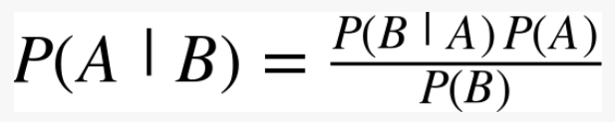

**Posterior Probability**

In Bayesian statistics we call the posterior probability of the random event the conditional probability we assign after the evidence is considered. Posterior probability distribution is defined as the probability distribution of an unknown quantity conditional on the evidence collected from an experiment treated as a random variable. We see this concept in action in softmax activation functions, explained later in this chapter, when the softmax activation functions converts the raw input value into posterior probabilities.

**Distributions**

A probability distribution is a specification of the stochastic structure of random variables. In statistics we rely on making assumptions about how the data is distributed to make inferences about the data. We want a formula that specifies how frequent values of observations in the distribution are and how values can be taken by points in the distribution. A common distribution is known as the “normal distribution” (also called “gaussian distribution”, or the “bell-curve”). We like to fit a dataset to a distribution because if the dataset is reasonable close to the distribution then we can make assumptions  based on the theoretical distribution in how we operate with the data.

Distributions can be classified as continuous (data can be any value within the range) or discrete. A discrete distribution has data that can assume only certain values. An example of a continuous distribution would be the normal distribution. An example of a discrete distribution would be the binomial distribution.

The normal distribution allows us to assume sampling distributions of statistics (e.g. “sample mean”) are normally distributed under specified conditions. The normal distribution, or “gaussian distribution”, was named after the 18th-century mathematician and physicist Karl Gauss. The normal distribution is defined by its mean and standard deviation and has generally the same shape across all variations.

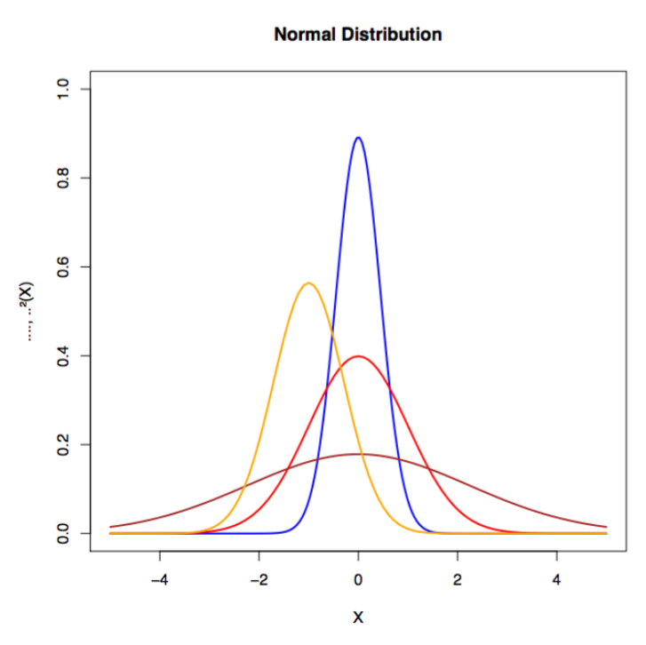

**Figure 1-5. Examples of Normal Distributions**

Other relevant distributions in machine learning include:

* binomial distribution
* inverse gaussian distribution
* log normal distribution

The distribution of the training data in machine learning is important to understand to better know how to vectorize the data for modeling.

**Central Limit Theorem**

If the sample size is sufficiently large the sampling distribution of the sample mean approximates the normal distribution. This holds true despite the distribution of the population from which the samples were collected.

Based on this fact we can make statistical inferences using tests based on the approximate normality of the mean. We see this hold true regardless if the sample is drawn from a population that is not normally distributed.

In computer science we see this used where an algorithm repeatedly draws samples of specified size from a nonnormal population. When we graph the histogram of the sample population of the draws form a normal distribution we can see this effect in action.

A long-tailed distribution (such as Zipf, power laws, and Pareto distributions) is a scenario where a high-frequency population is followed by a low-frequency population which gradually decreases in an asymptotic fashion. These distributions were discovered by Benoit Mandelbrot in the 1950’s and later popularized by the writer Chris Anderson in his book “The Long Tail: Why the Future of Business is Selling Less of More”.

An example would be ranking the items a retailer sells where a few items are exceptionally popular and then we see a large number of unique items with relatively small quantities sold. This rank-frequency distribution (primarily of popularity or “how many were sold”) many times will form power laws. From this perspective we can consider them to be long-tailed distributions.

We see these class of long-tailed distributions manifested when we see:

* Earthquake damage
  + damage gets worse as the scale of the quake increases so worse case shifts
* Crop Yields
  + we sometimes see events outside of the historical record whereas our model tends to get tuned around the mean
* Predicting fatality post-ICU visit
  + we can have events far outside the scope of what happens inside the ICU visit affecting mortality

These examples are relevant in the context of this book for classification problems because most statistical models depend on inference from lots of data. In the case that the more interesting events occur out in the tail of the distribution and we don’t have this represented in the training sample data then our model may perform unpredictably. This effect can be enhanced in non-linear models such as neural networks. We’d consider this situation the special case of the “in sample / out of sample” problem. Even a seasoned machine learning practitioner can be surprised at how well a model performs on a skewed training data sample yet fails to generalize well on the larger population of data.

Long-tailed distributions deal with the real possibility of events occurring that are 5x the standard deviation. We have to be mindful to get a decent representation of events in our training data to prevent overfitting the training data. We’ll look at ways to do this further on in our material on overfitting and then in [Chapter 4](https://www.safaribooksonline.com/library/view/Deep+Learning/9781491924570/ch04.html#major_architectures_of_deep_networks) on tuning

**Samples vs Population**

A population of data is defined as all of the units we’d like to study or model in our experiment. An example would be defining our population of study as “all java programmers in the state of Tennessee”.

A sample of data is a subset of the population of data that hopefully represents the accurate distribution of the data without introducing sampling bias (e.g. skewing the sample distribution based on how we sampled the population).

**Resampling Methods**

Bootstrapping and cross-validation are two common methods of resampling in statistics that are useful to machine learning practitioners. In the context of machine learning with bootstrapping we’re drawing random samples from another sample to generate a new sample that has a balance between the number of samples per class. This is useful when we’d like to model against a dataset with highly unbalanced classes.

Cross validation (also called “rotation estimation”) is a method to estimate how well a model generalizes on a training dataset. In cross validation we split the training dataset into N number of splits and then separate the splits into training and test groups. We train on the training group of splits and then test the model on the test group of splits. We rotate the splits between the two groups many times until we’ve exhausted all the variations. There is no hard number for a number of splits but researchers have found 10 splits to work well in practice. It is also common to see a separate portion of the held-out data used as a validation dataset during training.

**Selection Bias**

In selection bias we’re dealing with a sampling method that does not have proper randomization and skews the sample in a way such that the sample is not representative of the population we’d like to model. We need to be aware of selection bias when resampling datasets so that we don’t introduce bias into our models that will lower our model’s accuracy on data from the larger population.​

**Likelihood**

When we discuss the likeliness that an event will occur yet do not specifically reference its numeric probability we’re using the informal term, likelihood. Typically when we use this term we’re talking about an event that have a reasonable probability of happening but still may not. There may also be factors not yet observed that will influence the event as well. Informally likelihood is also used as a synonym for probability.

**How Does Machine Learning Work?**

In a previous section on solving systems of linear equations we introduced the basics of solving Ax = b. Fundamentally machine learning is based around algorithmic techniques to minimize the error in this equation through optimization.

In optimization we are focused on changing the numbers in the x column vector (parameter vector) until we find a good set of values that give us the closest outcomes to the actual values. Each weight in the weight matrix will be adjusted after the loss function calculates the error (based on the actual outcome as shown above as the b column vector) produced by the network. An error matrix attributing some portion of the loss to each weight will be multiplied by the weights themselves.

We discuss stochastic gradient descent further on in this chapter as one of the major methods to perform machine learning optimization and then we’ll connect these concepts to other optimization algorithms as the book progresses. We’ll also cover the basics of hyperparameters such as regularization and learning rate.

**Regression**

Regression refers to functions that attempt to predict a real value output. This type of function estimates the dependent variable by knowing the independent variable. The most common class of regression is linear regression based on the concepts we’ve previously described in modeling systems of linear equations. Linear regression attempts to come up with a function that describes the relationship between x and y, and, for known values of x, predicts values of y that turn out to be accurate.

**Setting Up the Model**

The prediction of a linear regression model is the linear combination of coefficients (from the parameter vector x) and then input variables (features from the input vector). We can model this with the equation:

y = a + Bx

where

a    y-intercept

B    input features

x     parameter vector

This equation expands to:



A simple example of a problem that linear regression solves would be predicting how much we’d spend per month on gasoline based on the length of our commute. Here, what you pay at the tank is a function of how far you drive. The gas costs are the dependent variable and the miles of the commute are the independent variable. It’s reasonable to keep track of these two quantities and then define a function

*cost = f (distance)*

such that we’ll reasonable predict our gasoline spending based on mileage. In this example we’d consider distance to be our independent variable and cost to be the dependent variable in our model f.

Other examples of linear regression modeling include:

* predicting weight as a function of height
* predicting a house’s sale price based on its square footage

**Visualizing Linear Regression**

Visually linear regression can be represented as finding a line that comes close to as many points as possible in a scatterplot of data as we see below in the diagram.

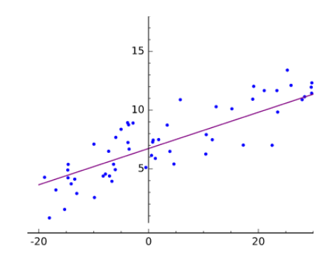

**Figure 1-6. Linear Regression Plotted**

*Fitting* is defining an function *f(x)* that produces *y-*values close to the measured or real-world *y*values. The line produced by *y = f(x)* comes close to the scattered coordinates, the pairs of dependent and independent variables.

**Relating the Linear Regression Model**

We can relate this function to the equation above Ax = b where A is the features (e.g. “weight” or “square footage”) for all of the input examples we want to model. Each input record is a row in the matrix A. The column vector b is the outcomes for all of the input records in the A matrix. Using an error function and an optimization method (e.g. “stochastic gradient descent”) we can find a set of x parameters such that we minimize the error across all of the predictions vs the true outcomes.

Using stochastic gradient descent, as we discussed above, we’d have 3 components to solve for our parameter vector x:

1. A hypothesis about the data
   * *the inner product of the parameter vector x and the input features (as displayed above)*
2. A cost function
   * *squared error (prediction - actual) of prediction*
3. An update function
   * *take the derivative of the squared error loss function (cost function)*

While linear regression deals with straight lines, nonlinear curve fitting handles everything else, most notably curves that deal with x to higher exponents than 1. (That’s why we hear machine learning sometimes described as “curve fitting”.) An absolute fit would hit every dot on scatterplot. Ironically, absolute fit is usually a very poor outcome, because it means your model has trained too perfectly on our training set, and has almost no predictive power beyond the data it has seen (e.g. “does not generalize well”) as we previously discussed.

**Classification**

Classification is modeling based on delineating classes of output based on some set of input features. If regression give us an outcome of "*how much*,” classification gives us an outcome "*what kind*.” The dependent variable *y* is categorical rather than numerical.

The most basic form of classification is a binary classifier that only has a single output with two labels (two classes, 0 and 1 respectively). The output can also be a floating point number between 0.0 and 1.0 to indicate a classification below absolute certaintity. In this case we need to determine a threshold (typically 0.5) where we delineate between the two classes. We often hear of these classes referred to in literature as the positive (e.g. 1.0) and then negative (e.g. 0.0) classifications. We’ll talk more about this in a future section on evaluating model performance.

Examples of binary classification include:

* classifying is someone has a disease or not
* classifying an email as spam or not spam
* classifying a transaction as fraudulent or nominal

Beyond two labels we can have classification models that have N labels where we’d score each of the output labels and then the label with the highest score is the output label. We’ll discuss this further in the chapter as we talk about neural networks with multiple outputs vs neural networks with a single output (binary classification). We’ll also discuss classification more in this chapter when we talk about logistic regression and then dive into the full architecture of neural networks.

**Recommendation**

Recommendation is the process of suggesting items to users of a system based on similar other users or other items they have looked at before. One of the more famous variations of recommendation algorithms is called Collaborative Filtering made famous by Amazon.com.

**Clustering**

Clustering is an unsupervised learning techniques that involves using a distance measure and iterative moving similar items more closely together. At the end of the process the items clustered most densely around n centroids are considered to be classified in that group. K-means clustering is one of the more famous variations of clustering in machine learning.

**Underfitting and Overfitting**

As we mentioned above, optimization algorithms first attempt to solve the problem of under-fitting; that is, of taking a line that does not approximate the data well, and making it approximate the data better. A straight line cutting across a curving scatter plot would be a good example of under-fitting as we can see in the diagram below.

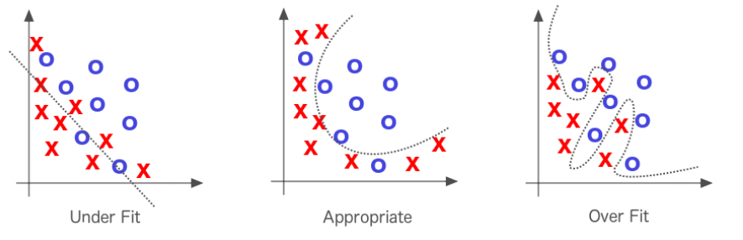

**Figure 1-7. Under-fitting and Over-fitting in Machine Learning**

If the line fits the data too well, we have the opposite problem called “over-fitting”. Solving under-fitting is the priority, but much effort in machine learning is spent attempting not to overfit the line to the data. When we say a model overfits a dataset we mean it may have a low error rate for the training data but it does not generalize well to the overall population of data we’re interested in.

Another way of explaining over-fitting is by thinking about probable distributions of data. The training set of data that we’re trying to draw a line through is just a sample of a larger unknown set, and the line we draw will have to fit the larger set equally well if it is to have any predictive power. We have to assume, therefore, that our sample is loosely representative of a larger set.

**Optimization**

The process described above of adjusting weights to produce more and more accurate guesses about the data is known as parameter optimization. We can think of this process like the scientific method. We formulate a hypothesis, test it against reality, and refine or replace that hypothesis again and again to better describe events in the world.

Every set of weights represents a specific hypothesis about what inputs mean; i.e. how they relate to the meanings contained in one’s labels. The weights represent conjectures about the correlations between networks’ input and the target labels they seek to guess. All possible weights and their combinations can be described as the hypothesis space of this problem. Our attempt to formulate the best hypothesis is a matter of searching through that hypothesis space, and we do so using error and optimization algorithms. The more input parameters we have, the larger the search space of our problem. Much of the work of learning is deciding which parameters to ignore and which to hear.

**The Decision Boundary and Hyperplanes**

When we mention the “decision boundary” we’re talking about the n-dimensional hyperplane created by the parameter vector in linear modeling.

Fitting lines to data by gauging their cost (that is, their distance from the ground-truth data points) is at the center of machine learning. The line should more or less fit the data, and it does so by minimizing the aggregate distance of all points from the line. You minimize the sum of the difference between the line at point x and the target point y it corresponds to. In a three-dimensional space, you can imagine the error-scape of hills and valleys, and picture your algorithm as a blind hiker who feels for the slope. An optimization algorithm like gradient descent is what tells the hiker which direction is downhill, so she knows where to step.

The goal is to find the weights that minimize the difference between what your network predicts (, or the dot-product of A and x) and what your test set knows to be true (b) as we saw above in diagram-X. The parameter vector (x) above is where you would find the weights. The accuracy of a network is a function of its input and parameters, and the speed at which it becomes accurate is a function of its hyperparameters.

**Hyperparameters**

In machine learning, we have both model parameters and then we have parameters we tune to make networks train better and faster. These tuning parameters are called hyperparameters, and they deal with controlling optimization function and model selection during training with our learning algorithm.

**Convergence**

Convergence refers to an optimization algorithm finding values for a parameter vector that give our optimization algorithm the smallest error across all training examples possible. The optimization algorithm is said to “converge” on the solution iteratively after it tries several different variations of the parameters.

The three important functions at work in machine learning optimization:

* parameters
  + transform input to help determine the classifications a network infers
* loss function
  + gauges how well it classifies (minimizes error) at each step
* optimization function
  + guides it toward the points of least error.

Now let’s take a closer look at one sub-class of optimization called “convex optimization”.

**Convex Optimization**

In convex optimization learning algorithms deal with convex cost functions. If the x axis represents a single weight, and the y axis represents that cost, then the cost will descend as low as 0 at one point on the x axis, and rise exponentially on either side, as the weight strays away from its ideal in two directions.   
   
We can also turn the idea of a cost function upside down as seen below in diagram-X:

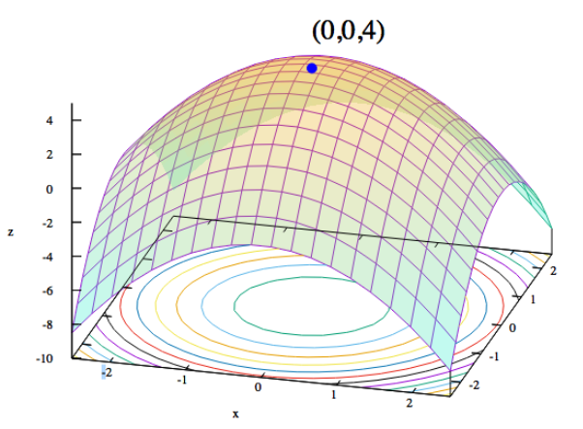

**Figure 1-8. Visualizing Convex Functions**

Another way to relate parameters to the data is with a maximum likelihood estimation, or MLE. The MLE traces a parabola whose edges point downward, with likelihood measured on the vertical axis and a parameter on the horizontal. Each point on the parabola measures the likelihood of the data given a certain set of parameters. The goal of MLE is to iterate over possible parameters until it finds the set that make the given data most likely.

In a sense, maximum likelihood and minimum cost are two faces on the same coin. Calculating the cost function of two weights against the error (which puts us in a three-dimensional space) will produce something that looks more like a sheet held at each corner and drooping convexly in the middle, a rather bowl-shaped function. The slopes of these convex curves allow our algorithm a hint in what direction to take the next parameter step as we’ll see in the gradient descent optimization algorithm.

**Gradient Descent**

In gradient descent we can imagine a landscape made of loss, whose hills represent a lot of error and whose valleys represent less error. We choose one point on that landscape at which to place your initial weight. We then may select the initial weight based on domain knowledge (if we’re training a network to classify a flower species you may know that petal length is important, but color isn’t). Or if we’re letting the network do all the work, we might choose the initial weights randomly.

The purpose is to move that weight downhill, to areas of lower error, as quickly as possible. An optimization algorithm like gradient descent can senses the actual slope of the hills with regard to each weight; i.e. it knows which direction is down. Gradient descent measures the slope (the change in error caused by a change in the weight) and takes the weight one step toward the bottom of the valley. It does so by taking a derivative of the loss function to produce the gradient. The gradient gives the algorithm the direction for the next step in the optimization algorithm as we see in the diagram below.

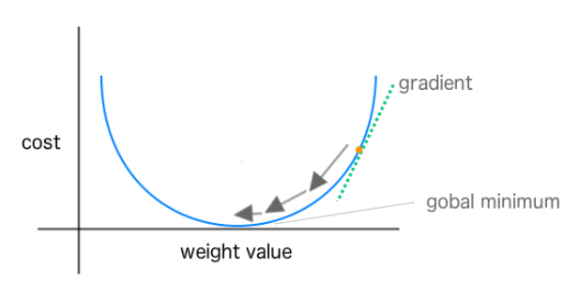

**Figure 1-9. Showing weight changes towards global minimum in Stochastic Gradient Descent**

The derivative measures “rate of change” of a function. In convex optimization we’re looking for the point where the derivative is equal to 0 for the function. This point is also know as the “stationary point” of the function or the minimum point. In optimization we consider optimizing a function to be minimizing a function (outside of inverting the cost function).

**What is Gradient?**

Gradient is defined as the generalization of the derivative of a function in one dimension to a function f in several dimensions. It is represented as a vector of n partial derivatives of the function f. It is useful in optimization in that the gradient points in the direction of the greatest rate of increase of the function where the magnitude is the slope of the graph in that direction.

Gradient descent calculates the slope of the loss function by taking a derivative, which should be a familiar term from calculus. On a two-dimensional loss function, the derivative would simply be the tangent of any point on the parabola; i.e. the change in y over the change in x, rise over run.

As we know from trigonometry, a tangent is just a ratio: the opposite side (which measures vertical change) over the adjacent side (which measures horizontal change) of a right triangle.

One definition of a curve is a line of constantly changing slope. The slope of each point on the curve is represented by the tangent line touching that point. Since slopes are derived from two points, how exactly does one find the slope of one point on a curve? We find the derivative by calculating the slope of a line between two points on the curve separated by a small distance and then slowing decreasing that distance until it approaches zero. In calculus, this is the idea of a limit.

This process of measuring loss and changing the weight by one step in the direction of less error is repeated until the weight arrives at a point beyond which it cannot go lower. It stops in the trough, the point of greatest accuracy. When using a convex loss function (typically in linear modeling) we see a loss function that has only a global minimum.

Linear modeling can be thought of in terms of 3 components to solve for our parameter vector x:

1. A hypothesis about the data
   * e.g. “the equation we use to make a prediction in the model”
2. A cost function
   * also called a loss function, e.g. “sum of squared errors”
3. An update function
   * we take the derivative of the loss function

Our hypothesis is the combination of the learned parameters x and the input values (features) in a way that gives us a classification or real valued (regression) output. The cost function tells us how far we are from the global minimum of the loss function and we use the derivative of the loss function as the update function to change the parameter vector x.

Taking the derivative of the loss function indicates for each parameter in x the degree to which we need to adjust the parameter to get closer to the 0-point on the loss curves. We’ll look closer at these equations later on in this chapter when we show how they work for both linear regression and logistic regression (classification).

However, in other non-linear problems we don’t always get such a clean loss curve. The problem with these other non-linear hypothetical landscapes is that there may be several valleys, and gradient descent’s mechanism for taking the weight lower cannot know if it has reached the lowest valley, or simply the lowest point in a higher valley, so to speak. The lowest point in the lowest valley is known as “the global minimum" while the nadirs of all other valleys are known as “local minima”. If gradient descent reaches a local minimum, it is effectively trapped, and this is one drawback of the algorithm. We’ll look at ways to overcome this issue later on in this book when we write about hyperparameters and learning rate.

A second problem that gradient descent encounters is with non-normalized features. When we write “non-normalized features” we mean features that can be measured by very different scales. If you have one dimension measured in the millions, and another in decimals, gradient descent will have a hard time finding the steepest slope to minimize error.

**Dealing with Normalization**

In [Chapter 8](https://www.safaribooksonline.com/library/view/Deep+Learning/9781491924570/ch08.html#vectorization) we take an extended look at methods of normalization in the context of vectorization and illustrate some ways to better deal with this issue.

**Stochastic Gradient Descent**

In gradient descent we’d calculate the overall loss across all of the training examples before calculating the gradient and updating the parameter vector. In stochastic gradient descent we compute the gradient and parameter vector update after every training sample. This has been shown to speed up learning and also parallelizes well as we’ll talk about more later in the book. Stochastic gradient descent is an approximation of “full batch” gradient descent.

**Mini-Batch Training and Stochastic Gradient Descent**

Another variant of stochastic gradient descent is to use more than a single training example to compute the gradient but less than the full training dataset. This variant is referred to as the “mini-batch” size of training with stochastic gradient descent and has been shown to be more performant than using only single training instances. Applying mini-batch to stochastic gradient descent has also shown to lead to smoother convergence as the gradient is computed at each step uses more training examples to compute the gradient.

As the mini-batch size increases the gradient computed is closer to the “true” gradient of the entire training set. This also gives us the advantage of better computational efficiency. If our mini-batch size is too small (e.g. “1 training record”) then we’re not using hardware as effectively as we could, especially for situations such as GPUs. Conversely, making the mini-batch size larger (beyond a point) can be inefficient as well because we can produce the same gradient with less computational effort (in some cases) with regular gradient descent.

**Quasi-Newton Optimization Methods**

Quasi-Newton optimization methods are iterative algorithms that involve a series of “line searches”. Their distinguishing feature with respect to other optimization methods is how they choose the search direction. These methods will be discussed more in later chapters of the book.

**The Jacobian and the Hessian**

The Jacobian is a m x n matrix containing the 1st order partial derivatives of vectors with respect to vectors.

The Hessian is the square matrix of 2nd order partial derivatives of a function. This matrix describes the local curvature of a function of many variables. We see the hessian matrix used in large scale optimization problems using newton-type methods as they are the coefficients of the quadratic term of a local taylor expansion. In practice the Hessian can be computationally difficult to compute. We tend to see quasi-newton algorithms used instead that approximate the hessian. An example of this class of quasi-newton optimization algorithm would be L-BFGS which we’ll cover more in [Chapter 2](https://www.safaribooksonline.com/library/view/Deep+Learning/9781491924570/ch02.html#foundations_of_nn_and_dl).

We won’t reference the Jacobian and the Hessian matricies much in this book but we want the reader to be aware of them and their place in the wider scope of the machine learning landscape.

**Generative vs Discriminative Models**

We can generate different types of output from a model depending on what type of model we setup. The two major types are generative models and discriminative models. Generative models understand how the data was created in order to generate a type of response or output. Discriminative models are not concerned with how the data was created and simply give us a classification or category for a given input signal. Discriminative models focus on closely modeling the boundary between classes and may yield a more nuanced representation of this boundary than a generative model. Discriminative models are typically used for classification in machine learning.

A generative model learns the **joint** probability distribution p(x, y) whereas a discriminative model learns the **conditional** probability distribution p(y|x). The distribution p(y|x) is the natural distribution for taking input x and producing an output (or classification) y, hence the name “discriminative model”. With generative models learning the distribution p(x,y), we see them used to generate likely output give a certain input. Generative models are typically setup as probabilistic graphical models which capture the subtle relations in the data.

**Logistic Regression**

Logistic Regression is a well-known type of classification in linear modeling. It works for both binary classification then for multiple labels in the form of multi-nomial logistic regression. Logistic regression is a regression model (technically) where the dependent variable is categorical (e.g. “classification”). The binary logistic model is used to estimate the probability of a binary response based on a set of one or more input variables (independent variables or “features”). This output is the statistical probability of a category given certain input predictors.

Similar to linear regression we can express a logistic regression modeling problem in the form of Ax = b where A is the features (e.g. “weight” or “square footage”) for all of the input examples we want to model. Each input record is a row in the matrix A and the column vector b is the outcomes for all of the input records in the A matrix. Using a cost function and an optimization method we can find a set of x parameters such that we minimize the error across all of the predictions vs the true outcomes.

Again we’ll use stochastic gradient descent to setup this optimization problem and we have 3 components to solve for our parameter vector x:

1. A hypothesis about the data
2. A Cost Function
   * “max likelihood estimation”
3. An Update Function
   * derivative of the cost function

In this case, the input is made of independent variables (e.g. the input columns or “features”) while the output is the dependent variables (e.g. “label scores”). An easy way to think about it is logistic regression function pairs input values with weights to determine if an outcome is likely or not. Let’s take a closer look at the logistic function.

**The Logistic Function**

In logistic regression we define the logistic function (“hypothesis”) as:

This function is useful in logistic regression as it takes any input on the range of negative to positive infinity and maps it to output on the range of 0.0 to 1.0. This allows us to interpret the output value as a probability. In the diagram below we can see a plot of the logistic function equation.

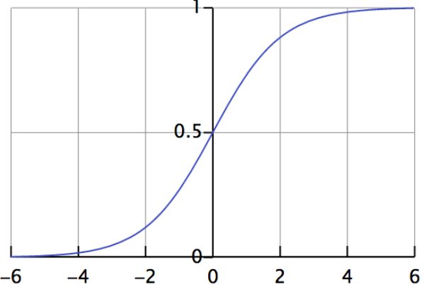

**Figure 1-10. Plot of the Logistic Function**

This function is known as a “continuous log-sigmoid function” with a range of 0.0 to 1.0. We’ll see this function covered again later in this chapter when we look at the sigmoid activation function.

**Understanding Logistic Regression Output**

The logistic function is often denoted with the Greek letter sigma, or , since the relationship between x and y on a two-dimensional graph resembles an elongated, wind-blown s whose maximum and minimum asymptotically approach 1 and 0, respectively.

If y is a function of x, and that function is sigmoidal or logistic, then the more x increases, the closer we come to 1/1, because e to the power of an infinitely large negative number approaches zero; in contrast, the more x decreases below zero, the more the expression  grows, shrinking the entire quotient. Since  is in the denominator, the larger it gets, the closer the quotient itself comes to zero.

With logistic regression, f(x) represents the probability that y equals 1 (i.e. is true) given each input x. If we are attempting to estimate the probability that an email is spam, and f(x) happens to equal 0.6, then we could paraphrase that by saying y has a 60 percent of being 1, or the email has a 60 chance of being spam, given the input. If we define machine learning as a method to infer unknown outputs from known inputs, then the parameter vector x in a logistic regression model determines the strength and certainty of our deductions.

**The Logit Transformation**

The logit function is the inverse of the logistic function (“logistic transform”).

**Evaluating Models**

Evaluating models is the process of understanding how well they give the correct classification and then measuring the value of the prediction in a certain context. Sometimes we only care how often a model gets any prediction correct and then in other times its important that the model gets a certain type of prediction correct more often than the others. We’ll cover topics like bad positives, harmless negatives, unbalanced classes, and unequal costs for predictions in this section. Let’s take a look at the basic tool of evaluating models called the “confusion matrix”.

**The Confusion Matrix**

The confusion matrix (also called “a table of confusion”) as we see below in [Figure 1-11](https://www.safaribooksonline.com/library/view/Deep+Learning/9781491924570/ch01.html#the-confusion-matrix) is a table of rows and columns that represent the predictions and the actual outcomes (labels) for a classifier. We use this table to better understand how well the model or classifier is performing based on giving the right answer at the right time.

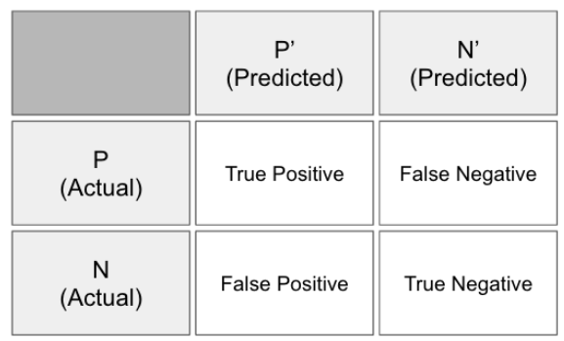

**Figure 1-11. The Confusion Matrix**

We measure these answers by counting the number of:

* true positives
  + positive prediction
  + label was positive
* false positives
  + positive prediction
  + label was negative
* true negatives
  + negative prediction
  + label was negative
* false negatives
  + negative prediction
  + label was positive

In traditional statistics a false positive is also known as “type I error” and a false negative is also known as “type II error”. By tracking these metrics we can get a more detailed analysis on the performance of the model beyond the basic percent of guesses that were correct. We can calculate different evaluations of the model based on combinations of the above four counts in the confusion matrix as displayed below:

 Accuracy:  0.94

 Precision: 0.8662

 Recall:    0.8955

 F1 Score:  0.8806

In the above example we can see four different common measures in the evaluation of machine learning models. We’ll cover each of them below but for now let’s start with the basics of evaluating model sensitivity vs model specificity.

**Sensitivity vs Specificity**

Sensitivity and specificity are two different measures of a binary classification model. The true positive rate measures how often we classify an input record as the positive class and its the correct classification. This is also called sensitivity or recall and an example would be classifying a patient as having a condition who was actually sick. Sensitivity quantifies how well the model avoids false negatives.

Sensitivity = TP / ( TP + FN )

If our model was to classify a patient from the previous example as not having the condition and they actually did not have the condition then this would be considered a true negative (also called specificity). Specificity quantifies how well the model avoids false positives.

Specificity = TN / ( TN + FP )

Many times we need to evaluate the trade-off between sensitivity and specificity. An example would to have a model which detects a serious sickness in patients more frequently because of the high cost to missing out on a truly sick patient. We’d consider this model to have low specificity. A serious sickness could be a danger to the patient’s life and to the others around them so our model would be considered to have a high sensitivity to this situation and its implications. In a perfect world our model is 100% sensitive (e.g. all sick are detected) and 100% specific (e.g. no one who is not sick is classified as sick).

**Accuracy**

Accuracy is the degree of closeness of measurements of a quantity to that quantity’s true value.

Accuracy = ( TP + TN ) / ( TP + FP + FN + TN )

Accuracy can be misleading in the quality of the model when the class imbalance is high. If we simply classify everything as the larger class our model will automatically get a large number of its guesses correct and provide us with a high accuracy score yet misleading indication of value based on a real application of the model (e.g. it will never predict the smaller class or rare event).

**Precision**

The degree to which repeated measurements under the same conditions give us the same results is called precision in the context of science and statistics. Precision is also known as the positive prediction value. While sometimes used interchangeable with accuracy in colloquial use they are defined differently in the frame of the scientific method.

Precision = TP / ( TP + FP )

A measurement can be accurate yet not precise, not accurate but still precise, neither accurate nor precise, or both accurate and precise. We consider a measurement to be valid if it is both accurate and precise.

**Recall**

This is the same thing as sensitivity described above and is also known as the true positive rate or the hit rate.

**F1**

In binary classification we consider the F1 score (or F-score, F-measure) to be a measure of a model’s accuracy. The F1 score is the harmonic mean of both the precision and recall measures (described previously) into a single score as defined below.

F1 = 2TP / ( 2TP + FP + FN )

We see scores for F1 scores between 0.0 and 1.0 where 0.0 is the worst score and 1.0 is the best score we’d like to see. The F1 score is typically used in information retrieval to see how well a model retrieves relevant results. In machine learning we see the F1 score used as an overall score on how well our model is performing.

**Context and Interpreting Scores**

Context can play a role in how we evaluate our model and dictate when we use different types of scores as described previously in this section. Class imbalance can play a large role in dictating choice of evaluation score and in many datasets we’ll find that the classes or label counts are not well balanced. Typical domains we see this in are:

* web click prediction
* ICU mortality prediction
* fraud detection

In these contexts an overall “percent correct” score may be misleading to the overall value, in practical terms, of the model. An example of this would be the PhysioNet Challenge dataset from 2012[11](https://www.safaribooksonline.com/library/view/Deep+Learning/9781491924570/ch01.html#idm139836506884608).

The goal of the challenge is to “predict in-hospital *mortality* with the greatest accuracy using a binary classifier.” The difficulty and challenge in modeling this dataset is that predicting a patient will live is the easy part because the bulk of examples in the dataset have outcomes where the patient does live. Predicting death accurately in this scenario is the goal and is where the model has the most value in the context of being clinically relevant in the real world. In this competition the scores were calculate as

Score = MIN( Precision, Recall )

This was setup such that it kept the contestants focused on not just predicting the patient would live most of the time and get a nice F1 score, but focus on predicting when the patient would die (keeping the focus on being clinically relevant). This is a great example of how context can change how we evaluate our models.

**Methods to Handle Class Imbalance**

In [Chapter 6](https://www.safaribooksonline.com/library/view/Deep+Learning/9781491924570/ch06.html#tuning_deep_networks) we’ll illustrate practical ways to deal with class imbalance. We’ll take a closer look at the different facets of class imbalance and error distributions in the context of classification and regression.

**Building an Understanding of Machine Learning**

In this chapter we introduced the core concepts needed for practicing machine learning. We looked at the core mathematical concepts of modeling based around the equation:

Ax = b

We also looked at the core ideas of getting features into the matrix A, ways to change the parameter vector x, and setting the outcomes in the vector b. We illustrated some basic ways to change the parameter vector x to minimize the score (or “loss”) of the objective function.

As we move forward in this book we’ll continue to expand on these key concepts. We’ll see how neural networks and Deep Learning are based on these fundamentals but add more complex ways to create the A matrix, change the x parameter vector through optimization methods, and measure loss during training. Let’s now move on to [Chapter 2](https://www.safaribooksonline.com/library/view/Deep+Learning/9781491924570/ch02.html#foundations_of_nn_and_dl) where we build further on these concepts with the basics of neural networks.

[1](https://www.safaribooksonline.com/library/view/Deep+Learning/9781491924570/ch01.html#idm139836507711616-marker) http://infolab.stanford.edu/pub/voy/museum/samuel.html

[2](https://www.safaribooksonline.com/library/view/Deep+Learning/9781491924570/ch01.html#idm139836519111952-marker) https://www2.eecs.berkeley.edu/Faculty/Homepages/russell.html

[3](https://www.safaribooksonline.com/library/view/Deep+Learning/9781491924570/ch01.html#idm139836519110992-marker) http://norvig.com/

[4](https://www.safaribooksonline.com/library/view/Deep+Learning/9781491924570/ch01.html#idm139836519109952-marker) http://aima.cs.berkeley.edu/

[5](https://www.safaribooksonline.com/library/view/Deep+Learning/9781491924570/ch01.html#idm139836507705024-marker) http://scholar.utc.edu/theses/184/ and http://www.aaai.org/ocs/index.php/IAAI/IAAI09/paper/viewFile/235/1030

[6](https://www.safaribooksonline.com/library/view/Deep+Learning/9781491924570/ch01.html#idm139836507702624-marker) https://mitpress.mit.edu/books/ant-colony-optimization

[7](https://www.safaribooksonline.com/library/view/Deep+Learning/9781491924570/ch01.html#idm139836516025792-marker) Gatys (et. al, 2015) “A Neural Algorithm of Artistic Style” http://arxiv.org/pdf/1508.06576v1.pdf

[8](https://www.safaribooksonline.com/library/view/Deep+Learning/9781491924570/ch01.html#idm139836507342704-marker) http://mason.gmu.edu/~jgentle/books/matbk/index.htm

[9](https://www.safaribooksonline.com/library/view/Deep+Learning/9781491924570/ch01.html#idm139836508144448-marker) http://archive.ics.uci.edu/ml/datasets/Iris

[10](https://www.safaribooksonline.com/library/view/Deep+Learning/9781491924570/ch01.html#idm139836507165344-marker) http://shop.oreilly.com/product/0636920023074.do

[11](https://www.safaribooksonline.com/library/view/Deep+Learning/9781491924570/ch01.html#idm139836506884608-marker) https://physionet.org/challenge/2012/

* [Copy](https://www.safaribooksonline.com/library/view/Deep+Learning/9781491924570/ch01.html)
* [Add Highlight](https://www.safaribooksonline.com/library/view/Deep+Learning/9781491924570/ch01.html)
* [Add Note](https://www.safaribooksonline.com/library/view/Deep+Learning/9781491924570/ch01.html)

You have 1 day left in your trial, Newsletter7. Subscribe today. [See pricing options.](https://www.safaribooksonline.com/subscribe/)

[Back to top](https://www.safaribooksonline.com/library/view/Deep+Learning/9781491924570/ch01.html)

* [Recommended](https://www.safaribooksonline.com/r/)
* [Queue](https://www.safaribooksonline.com/s/)
* [History](https://www.safaribooksonline.com/history/)
* [Topics](https://www.safaribooksonline.com/topics?q=*&limit=21)
* [Tutorials](https://www.safaribooksonline.com/tutorials/)
* [Settings](https://www.safaribooksonline.com/u/)
* [Blog](https://www.safaribooksonline.com/blog/)
* [Support](https://www.safaribooksonline.com/public/support)
* [Get the App](https://www.safaribooksonline.com/apps/)
* [Sign Out](https://www.safaribooksonline.com/accounts/logout/)

© 2017 [Safari](https://www.safaribooksonline.com). [Terms of Service](https://www.safaribooksonline.com/terms/) / [Privacy Policy](https://www.safaribooksonline.com/privacy/)